

NED University of Engineering and Technology

Feedback Control System (EE-374)

(CEP)

|  |  |
| --- | --- |
| **Name** | **Roll number** |
| Ahsen Muhammad Adnan | EE-18233 |
| Muhammad Muneeb Waseem | EE-18205 |
| Saim Hussain Khan | EE-18229 |
| Ahsan Kamal | EE-18208 |
| Syed Muhammad Samad Hussain Zaidi | EE-18204 |

Section: F

Batch: 2018

Electrical Engineering Department

**Table of contents:**

1. **Introduction**
2. **Objective**
3. **Hardware**
4. **Arduino code**
5. **Graphical representation**
6. **Tasks performed**
7. **Conclusion**
8. **References**

**Introduction:**

While both A.C. and D.C. motors serve the same function of converting electrical energy into mechanical energy, they are powered, constructed and controlled differently [1]. D.C. motors are powered from direct current (D.C.), such as batteries, D.C. power supplies or an AC-to-DC power converter as opposed to AC motors. Brushes and a commutator are used in D.C winding field motors, which contribute to the maintenance, limit the speed, and lower the life expectancy of brushed D.C. motors. The speed of a D.C. motor is controlled by varying the armature winding’s current while the speed of an A.C. motor is controlled by varying the frequency, which is commonly done with an adjustable frequency drive control [2]. Thus, the armature control method is exactly what we have used for our complex engineering problem. To understand how the armature controls the speed of the motor we will take a simple electrical circuit as shown below,

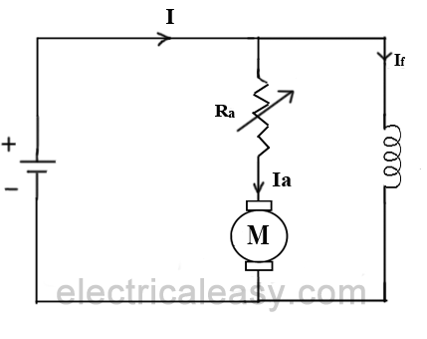

As clearly visible in the above diagram, Speed of a dc motor is directly proportional to the back emf Eb and Eb = V - IaRa. That is, if the supply voltage V and armature resistance Ra are constant, the speed is proportional to the armature current Ia. As a result, when we add resistance in series with the armature, Ia lowers, and the speed decreases as well. The lower the speed, the larger the resistance in series with the armature. The method explained above is put action in this problem and the results are illustrated in this report. The problem has been completed while keeping in mind of all the tasks that are required, some were optional while others were compulsory thus were held of utmost importance. From graphical representation to bode plots, the complete analysis of the problem has been performed. The coding was written on Arduino and the program was easily initiated in the hardware. Lastly we have presented our results in tables, graphs and wordings for all the analysis performed throughout the problem solving.

**Objective:**

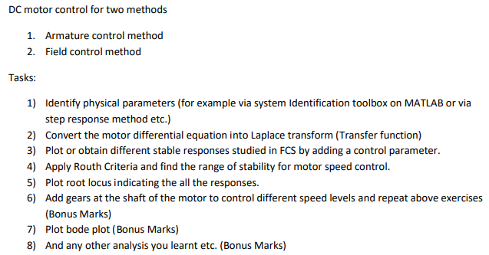

**Hardware:**

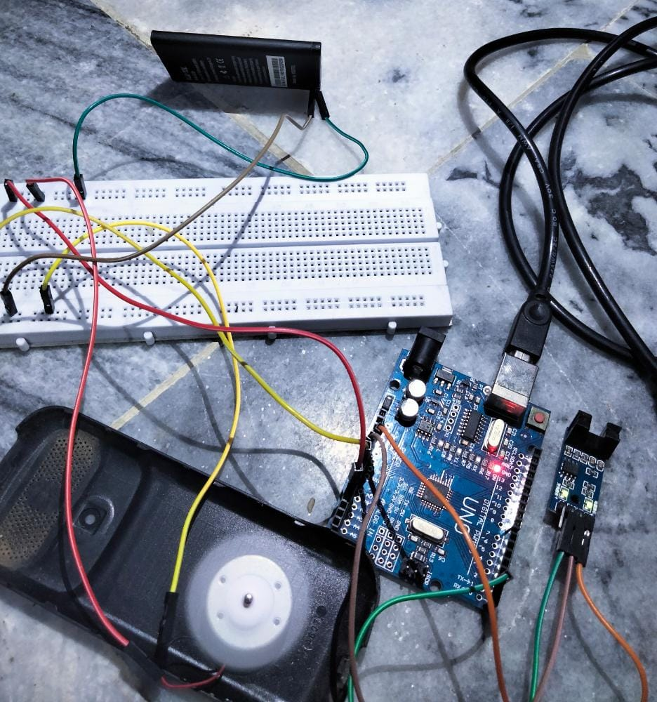

**Components,**

* Speed sensor
* Arduino UNO
* Breadboard
* Jumpers (for connection)
* 3.8 V Battery (for input voltage)
* DC motor

**Arduino:**

**Code,**

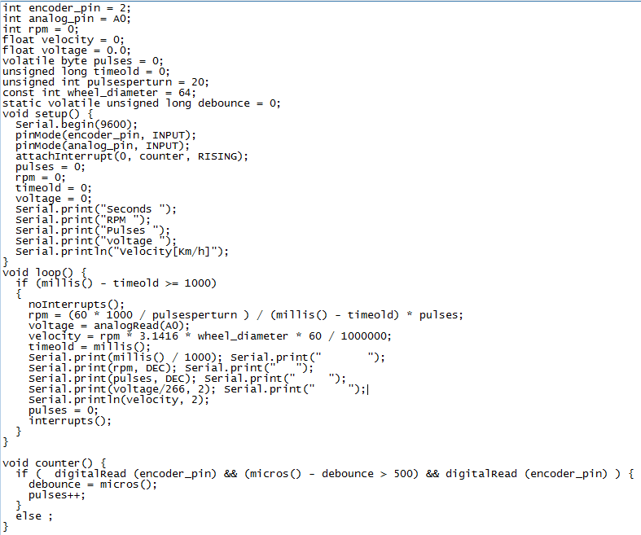

**Readings Obtained,**

|  |  |  |
| --- | --- | --- |
| Time/s | Voltage/V | Speed |
| 0 | 0 | 0 |
| 1 | 2.78 | 130 |
| 2 | 2.8 | 115 |
| 3 | 2.8 | 112 |
| 4 | 3 | 105 |
| 5 | 3.1 | 100 |
| 6 | 3.1 | 95 |
| 7 | 3.2 | 90 |
| 8 | 3.25 | 112 |
| 9 | 3.25 | 100 |
| 10 | 3.3 | 98 |
| 11 | 3 | 95 |
| 12 | 3.1 | 100 |
| 13 | 3.25 | 100 |
| 14 | 3.25 | 101 |
| 15 | 3.3 | 105 |
| 16 | 3.3 | 90 |
| 17 | 3 | 100 |
| 18 | 3.2 | 110 |
| 19 | 3.3 | 110 |

**Graphical representation of Speed and Voltage:**

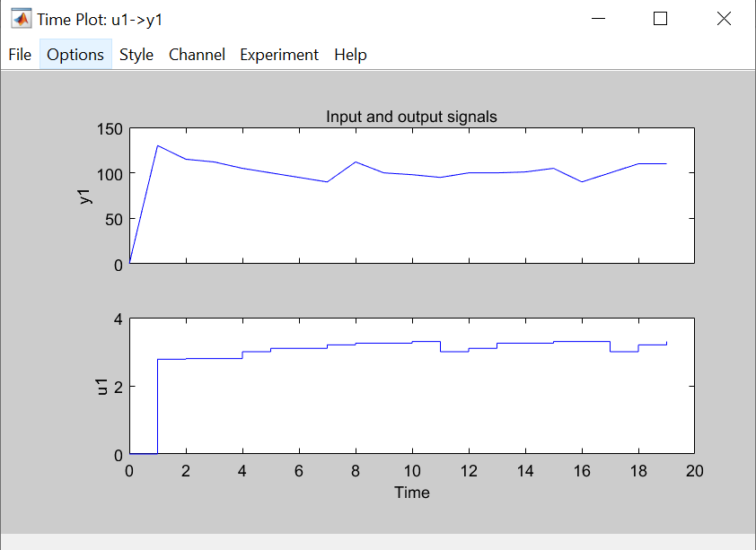

**Task 1:**

(Optional)

**Task 2:**



**Response,**

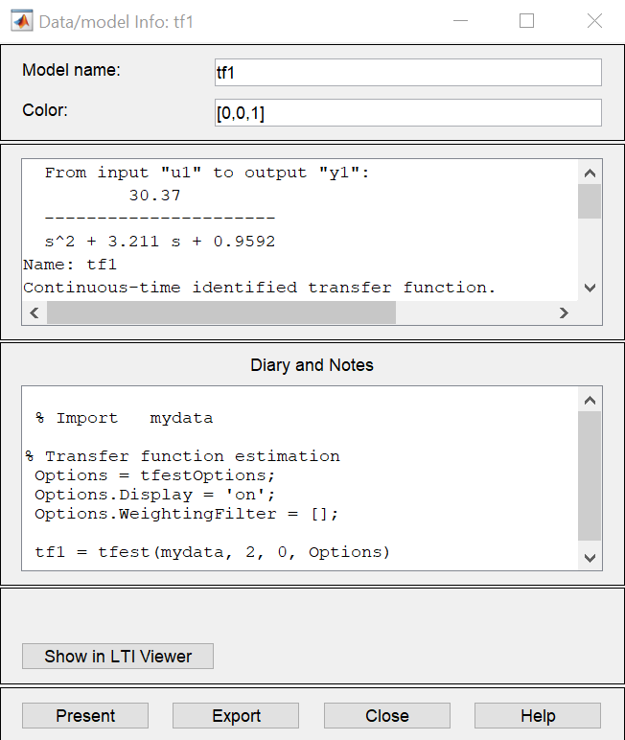

**Task 3:**



**Response,**

Below is an image of the step response graph, the graph is a curve and not a straight line. For step input, only gain Kp will exist and rest Kv and Ka will become zero for the step input. The graph rises to a peak value of 32 after 15 seconds and that peak value is maintained throughout the passage of time.

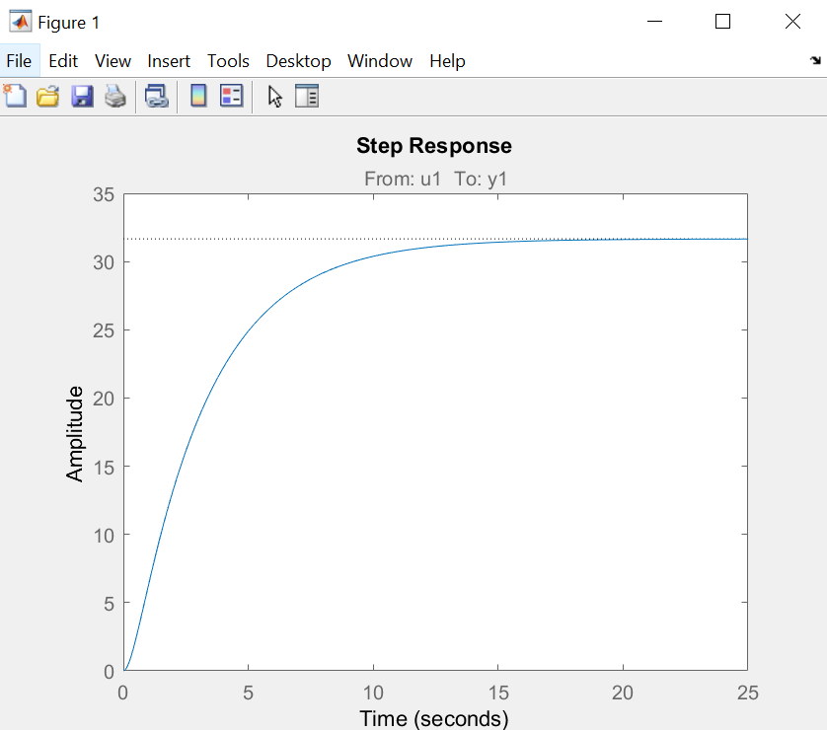

Below is an image of the impulse response graph, the graph is a curve and not a straight line. The graph rises to a peak value of 8 after 1 second and that peak value instantly starts dropping until it reaches completely zero after 19 seconds, reaching completely zero at 20 seconds.

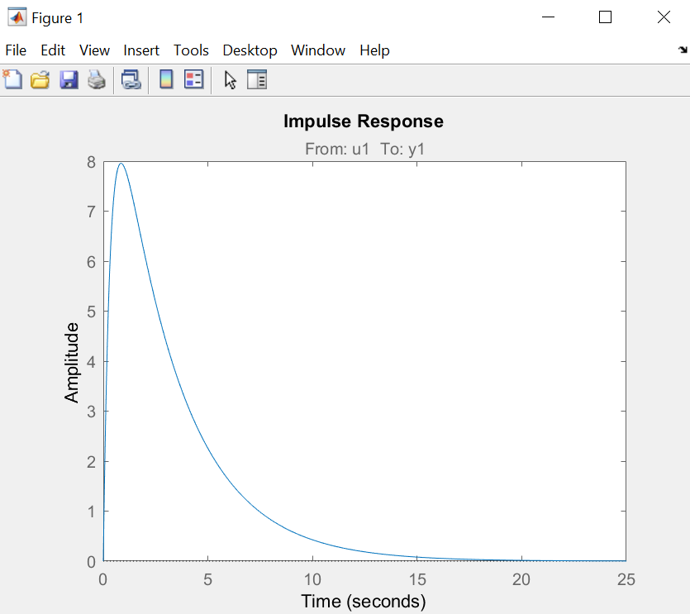

Below is the ramp response. For this, only Kv gain will exist and rest Ka will be zero and Kp will be infinite.

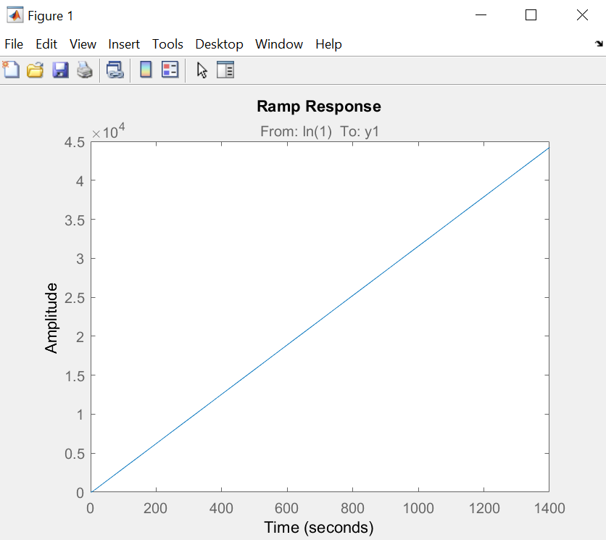

**Task 4:**



**Response,**

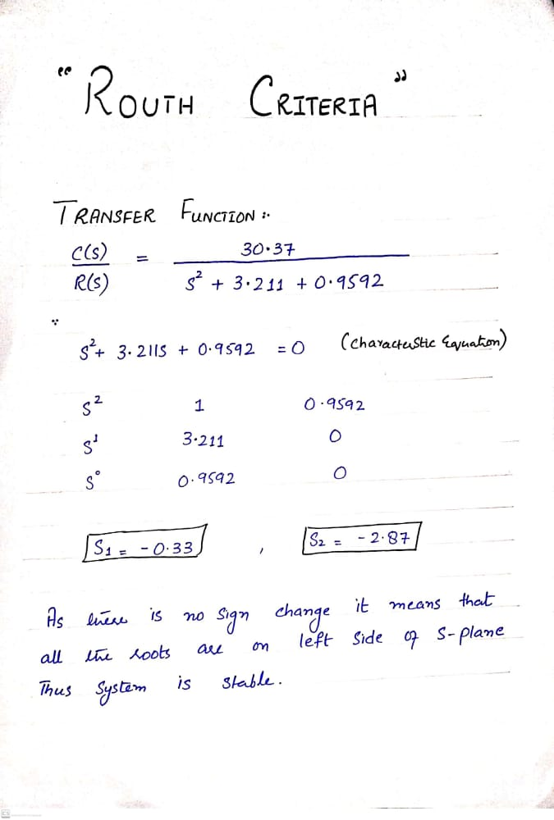

As system roots are found to be -0.33 and -2.87 respectively so the stability is observed to lie between these mentioned roots.

**Task 5:**



**Response,**

The root locus plot below shows us the responses on a concise plot with an imaginary and a real axis. We found two poles at -0.3 and -2.9 on real or sigma axis respectively.

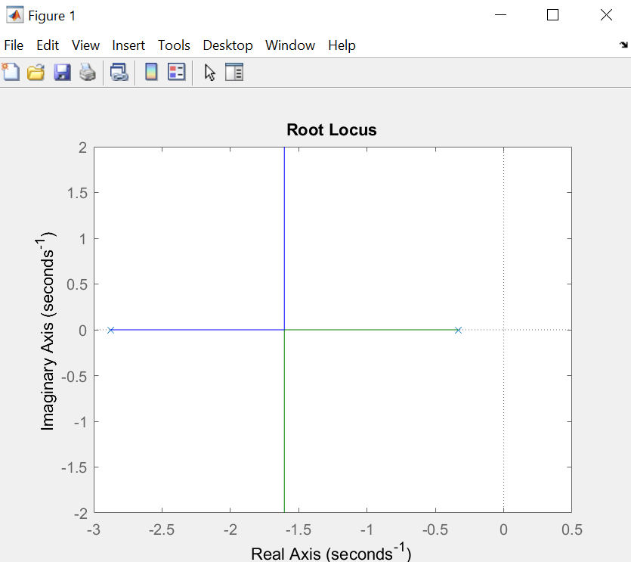

In the below graph of pole zero we are again shown to have two poles on the plot with the points -2.9 and -0.3 on sigma axis respectively.

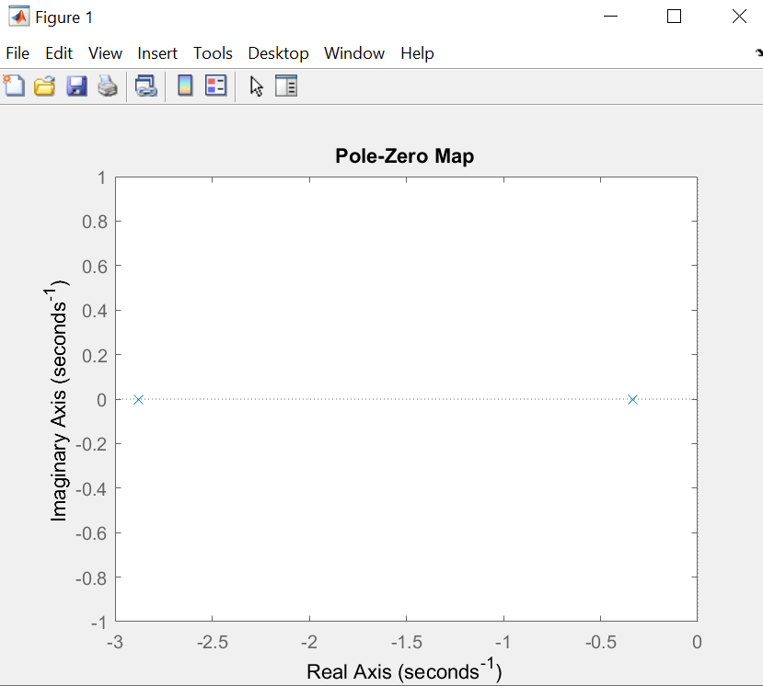

**Task 6:**

(Optional)

**Task 7:**



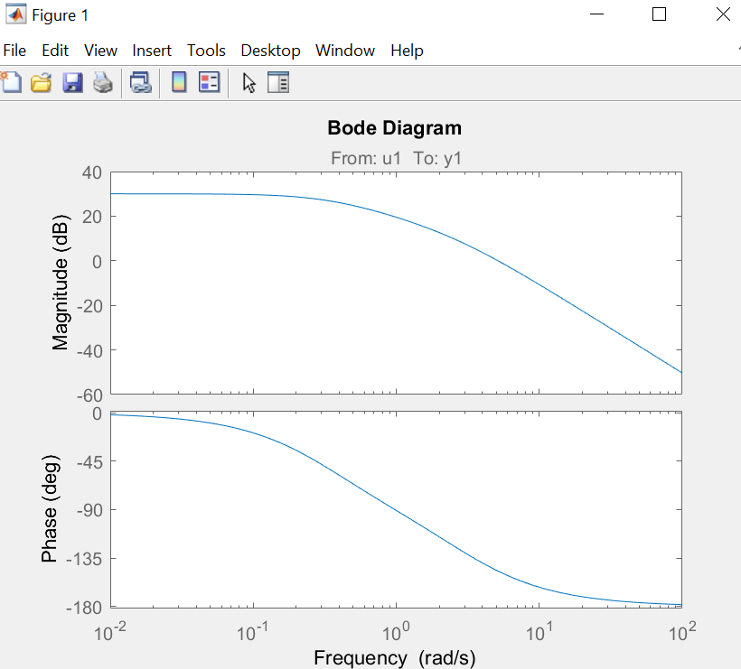

As visible above in fig.1, the Bode diagram has been issued showing, magnitude with respect to the frequency and phase with respect to the frequency.

**Conclusion:**

We controlled the speed of the DC motor using the armature control method. While doing so we used all the theoretical and analytical methods taught to us in FCS to complete the tasks provided. We found out the transfer function, plotted different response graphs. Like the step, ramp and impulse response graphs. In order to check the stability of our motor, we also applied the routh criteria. Leading us to the conclusion that our motor is indeed stable. The range for its stability was also found out and shown by the root locus.

This complete complex engineering problem is in fact our practical implementation of all the theoretical studies made in FCS. From solving the mathematical models of systems to determining the transfer functions and from constructing differential equations to checking the stability of the feedback control system. These analysis of the DC motor have trained us to the point where we now know how to properly analyze a system in order to optimize it. All the tasks provided below completed single but important parts of the project helping us to understand the importance of feedback in any system. We have implemented many techniques that have helped us deeply understand the depths and importance of feedback control systems in our daily engineering lives.

**References:**

[1] Saeed Niku. Introduction to Robotics: Analysis, Control, Applications. 2nd ed. John Wiley & Sons, Inc., 2011. Page 280.

[2] Robert S. Carrow. Electrician’s technical reference: Variable frequency drives. Delmar Thomson Learning, 2001. Page 45.